The Open Source Conventions & Google Dorking

Licenses
Open source licenses grant permission for anybody to use, modify, and share licensed software for any purpose, subject to conditions preserving the provenance and openness of the software.

1.MIT License
A short and simple permissive license with conditions only requiring preservation of copyright and license notices. Licensed works, modifications, and larger works may be distributed under different terms and without source code.
Use this license for simple projects , startups , etc.
Permissions
- Commercial use
- Distribution
- Modification
- Private use
Conditions
- License and copyright notice
Limitations
- Liability
- Warranty
2.Apache License
A permissive license whose main conditions require preservation of copyright and license notices. Contributors provide an express grant of patent rights. Licensed works, modifications, and larger works may be distributed under different terms and without source code.
Use this license when you need to work in a community , collaborative projects.
Permissions
- Commercial use
- Distribution
- Modification
- Private use
- Patent use
Conditions
- License and copyright notice
- state changes
Limitations
- Liability
- Warranty
- Trademark use

3.GNU General Public License
Permissions of this strong copyleft license are conditioned on making available complete source code of licensed works and modifications, which include larger works using a licensed work, under the same license. Copyright and license notices must be preserved. Contributors provide an express grant of patent rights.
Use this license when you are building a community-driven project , want to protect against commercial exploitation , etc.

Permissions
- Commercial use
- Distribution
- Modification
- Private use
- Patent use
Conditions
- License and copyright notice
- state changes
- same license
- disclose source
Limitations
- Liability
- Warranty

4.ISC License
A permissive license lets people do anything with your code with proper attribution and without warranty. The ISC license is functionally equivalent to the MIT license, removing some language that is no longer necessary.

Permissions
- Commercial use
- Distribution
- Modification
- Private use
Conditions
- License and copyright notice
Limitations
- Liability
- Warranty

The Open-Source Workflow
Contributing to an open-source project, even a small bug fix, typically follows a standard, three-step workflow. This process ensures that all changes are reviewed by the project's maintainers and align with the project's standards before being merged into the main codebase.
1. Fork the repository
The first step is to create a personal copy of the original project's repository. This is done by clicking the "Fork" button on the project's GitHub page. This creates a new repository under your own GitHub account that you have full control over. You can make any changes you want to this copy without affecting the original project.
2. Make Your Changes
After forking, you'll clone your new repository to your local machine. From there, you can create a new branch, write your code, fix a bug, or add a new feature. Once changes are complete, you'll commit them and push them back to forked repository on GitHub.
3. Create a Pull Request
When your changes are ready, you will create a "Pull Request" (PR) from your forked repository to the original project. The pull request is a formal proposal to the project's maintainers to "pull" your changes into their main branch. The maintainers will then review your code, provide feedback, and may ask for revisions. Once they are satisfied, they will merge your changes, and your contribution will become a part of the official project.

Analyzing the React Project
React is one of Facebook’s first open source projects that is both under very active development and is also being used to ship code to everybody on facebook.com.

License : React uses MIT license .
The MIT License permits developers to:
- Use the software for any purpose, including commercial projects.
- Modify the source code.
- Distribute the original or modified code.
- Sublicense the software to others.
- Use the code in both private and open-source projects.

Contributing guidelines :
As mentioned earlier , react also follows a standard contributing guidelines. It is provided in the CONTRIBUTING.md file .
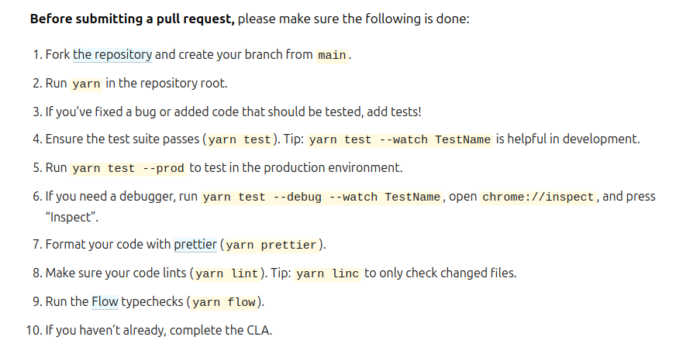

Code of conduct :
The Code of Conduct and specific issue labels are essential for creating a welcoming environment for new contributors. A Code of Conduct is a document that outlines a community's expectations for behavior. For a project like React, which adopts the Contributor Covenant, it's a formal statement that the project is dedicated to providing a harassment-free and inclusive environment for everyone, regardless of their background. Its importance lies in setting a clear standard of professionalism and respect. This helps new contributors feel safe and valued, knowing that if they face any negative behavior, there is a clear process for addressing it. Ultimately, it builds trust and encourages a diverse group of people to get involved.
Community :
A project's success depends on its community. React uses a Code of Conduct to set clear behavioral standards, making the environment welcoming to everyone. React shows that a project's health isn't just about the code, it's also about a strong, supportive, and inclusive community that encourages new people to get involved.

Google Dorking
url : https://tryhackme.com/room/googledorking
